# **Fruitipedia App - Django Basics Exam Prep II**

*The app allows the user to browse different fruits including their nutrition info, description, name, and image. The user can create, edit, or delete fruits at any time. He/ She can also edit or delete his/ her profile.*

## Skeleton

All essential **HTML** pages, **images**, and **CSS** resources for the project have been provided to you.

## Structure

Establish a well-organized project structure by initiating a **minimum** of **two** Django **apps** and configuring the corresponding URLs.

You have the flexibility to utilize **both Function-Based** **Views** and **Class-Based Views** as needed.

Adhere to best practices and uphold the separation of concerns principle for a robust and maintainable codebase.

## Database

You will need **2 models**:

### Profile Model

* + **First Name**
    - Character field, **required.**
    - It should consist of a **maximum of 25 characters and** a **minimum of 2 characters.**
    - The first name **must start with a letter**. Otherwise raise **ValidationError** with the following message: "**Your name must start with a letter!**"
  + **Last Name**
    - Character field, **required.**
    - It should consist of a **maximum of 35 characters and** a **minimum of 1 character.**
    - The last name **must start with a letter**. Otherwise raise **ValidationError** with the following message: "**Your name must start with a letter!**"
  + **Email**
    - Email field, **required**, **unique**.
    - It should consist of a **maximum** **of 40 characters.**
  + **Password**
    - Character (password) field, **required**.
    - It should consist of a **maximum of 20 characters and** a **minimum** **of 8 characters.**
    - Help text: **"*Password length requirements: 8 to 20 characters"**
  + **Image URL**
    - URL field, **optional**.
  + **Age**
    - Integer field, **optional**.
    - The age **default value should be 18**.

### Fruit Model

* + **Name**
    - Character field, **required**, **unique.**
    - It should consist of a maximum of **30 and** a **minimum of 2 characters**.
    - The name should contain **only letters**. Otherwise raise a **ValidationError** with the following message: "**Fruit name should contain only letters!**"
    - A custom **error message** for **unique constraint: "This fruit name is already in use! Try a new one."**
  + **Image URL**
    - URL field, **required.**
  + **Description**
    - Text field, **required.**
  + **Nutrition**
    - Text field, **optional.**
  + **Owner**
    - A **foreign key** to the **Profile** model.
    - Establishes a **many-to-one** relationship with the **Profile** model, associating each fruit with a profile.
    - The **ON DELETE** constraint must be **configured** to an **appropriate value** in alignment with the specified **additional tasks**.
    - This field should remain **hidden** in forms.

**Note: the project will be examined only on the user side; models will NOT be tested on the admin site with a superuser profile.**

## Routes

* <http://localhost:8000/> - Index page
* <http://localhost:8000/dashboard/> - Dashboard page
* <http://localhost:8000/fruit/create/> - Fruit create page
* [http://localhost:8000/fruit/<fruitId>/details/](http://localhost:8000/fruit/%3cfruitId%3e/details/) - Fruit details page
* [http://localhost:8000/fruit/<fruitId>/edit/](http://localhost:8000/fruit/%3cfruitId%3e/edit/) - Fruit edit page
* [http://localhost:8000/fruit/<fruitId>/delete/](http://localhost:8000/fruit/%3cfruitId%3e/delete/) - Fruit delete page
* <http://localhost:8000/profile/create>/ - Profile create page
* <http://localhost:8000/profile/details/> - Profile details page
* <http://localhost:8000/profile/edit/> - Profile edit page
* <http://localhost:8000/profile/delete/> - Profile delete page

## Pages

### Base Template - 10p

**Template file**: **"base.html"**

Create a **base template** to be **inherited** by all other templates in the project. This base template should encompass project **metadata** within the <head> tag, along with a consistent **navigation bar** and **footer** for every web page.

**Navigation bar**:

* **"Fruitipedia"** link, which leads to the **index** page.
* **"Create Profile"** link, which leads to **create profile** page.
* **"Dashboard"** link, which leads to the **dashboard** page.
* **"Add Fruit"** link, which leads to the **create fruit** page.
* **"Profile"** link, which leads to the **profile details** page.

Note that the **"Create Profile"** link on the navigation bar is **only visible** when the user **has NOT created** a **profile yet**, while the **"Dashboard"**, **"Add Fruit"**, and **"Profile"** links are **only visible** when the user **has a profile**.

This template lacks a direct path and is **inaccessible** via **URL**.

### Index page - 5p

**Template file**: **"index.html"**

The page displays:

* A **navigation bar** as described above

Keep in mind that the **"Create Profile"** link on the navigation bar is **only visible** when the user **has NOT created** a **profile yet**:

The **"Dashboard"**, **"Add Fruit"**, and **"Profile"** links on the navigation bar are **only visible** when the user **has a profile:**

### Create Profile Page - 10p

**Template file**: **"create-profile.html"**

The page displays:

* A **navigation bar** with:
* **"Fruitipedia"** link, which leads to the **index** page.
* **"Create Profile"** link, which leads to **create profile** page.
* A **profile** **creation form** consisting of:
* A **"First Name"** field, a placeholder **"First Name"** and **no label**
* A **"Last Name"** field, a placeholder **"Last Name"** and **no label**
* An **"Email"** field, a placeholder **"Email"** and **no label**
* A **"Password"** field, a placeholder **"Password"**, a help text **"*Password length requirements: 8 to 20 characters"** and **no label**
  + When the user enters his/her password, the symbols shall be **masked** – **not visible**.
* Utilize a suitable **widget** to **mask** **characters** for enhanced **security** and **privacy**.
* A button **"Create"**
* When you **click** on it **if** the profile is **successfully created**, you should be **redirected** to the **dashboard page**.
* Otherwise, the form should show the **appropriate validation errors**.

### Dashboard Page - 10p

**Template file**: **"dashboard.html"**

The **dashboard page** shows **all fruits** which have been **created** and **stored** in the **database.**

If there are **no fruits created yet**, the page should have the following:

* A navigation bar, as shown below.
* A heading **"No fruit info yet."**

If there are **fruits,** the page should have the following:

* A navigation bar, as shown below.
* A division for each fruit, showing:
* The fruit's **image**
* The fruit's **name**
* The fruit's **description**. The description should show **only** **the first 50 characters!**
* A **button** **"More Info"** leading to the **details page** for the selected fruit

### Create Fruit Page - 10p

Template file: **"create-fruit.html"**

The page consists of:

* A **navigation bar,** as shown below.
* A **fruit** **creation form** consisting of:
* A **"Name"** field, a placeholder **"Fruit Name"** and **no label**
* An **"Image URL"** field, a placeholder **"Fruit Image URL"** and **no label**
* A **"Description"** field, a placeholder **"Fruit Description"** and **no label**
* A **"Nutrition"** field, a placeholder **"Nutrition Info"** and **no label**
* A button **"Add Fruit"**
* When you **click** on it **if** the fruit is **successfully created**, you should be redirected to the **dashboard page**.
* Otherwise, the form should show the **appropriate validation errors**.
* **Associate** the new **fruit post** with the **user profile** you already have in the database.

### Fruit Details Page - 10p

Template file: **"details-fruit.html"**

This page contains a fruit’s information. It should have the following:

* The **fruit's image**
* The **fruit's name**
* The **fruit's description**
* The **fruit's nutrition info**, starting with a **paragraph "Nutrition"** (**visible** even if there is **no** nutrition info)
* An **"Edit"** button that leads to the **edit fruit page**
* A **"Delete"** button that leads to the **delete fruit page**

### Edit Fruit Page - 10p

Template file: **"edit-fruit.html"**

On the page, the form must be **pre-filled** with **information** about the **fruit** you selected **to edit.** Each field has a **label**: **"Name:"**, **"Image URL:"**, **"Description:"**,and **"Nutrition:"**.

When you click on the **"Edit"** button:

* **If** the fruit is **successfully edited**,you should be redirected to the **dashboard** **page**.
* **Otherwise**, the form should show the **appropriate validation errors**.

### Delete Fruit Page - 10p

Template file: **"delete-fruit.html"**

On the page, the form must be **pre-filled** with the **fruit's information**, and **all the fields** should be **disabled.**

Each field has **a label: "Name:"**, **"Image URL:"** and **"Description:"**.

When you click on the **"Delete"** button, the **fruit** is **deleted from the database**, and you should be redirected to the **dashboard page**.

The deleted fruit should be **no longer visible** in the **app**.

### Profile Details Page - 10p

Template file: **"details-profile.html"**

This page contains the **user's information**. It should have the following:

* A **profile** **picture**.
  + - * If **no picture is given**, the page should show a **default profile picture** (in the static/images folder)
* **First name** and **last name**:
* The **email**
* The **age**
* The **total number** of **fruit posts** that the **user has**. Display **0** (zero) if there are **no** **fruit** **posts**.
* An **"Edit"** button that leads to the **edit profile page**
* A **"Delete"** button that leads to the **delete profile page**

**If the user has a profile picture:**

**If the user doesn't have a profile picture:**

### Edit Profile Page - 10p

Template file: **"edit-profile.html"**

On the page, the form must be **pre-filled** with the **information** of the **profile** you **selected** to **edit**.The profile **edition form** has **fields** as shown below:

* A **"First Name:"** field
* A **"Last Name:"** field
* An **"Image URL:"** field
* An **"Age:"** field

**All** fields have **labels**.

When you click on the **"Edit"** button:

* **If** the profile is **successfully edited**,you should be **redirected** to the **profile details page**.
* **Otherwise**, the form should show the **appropriate validation errors**.

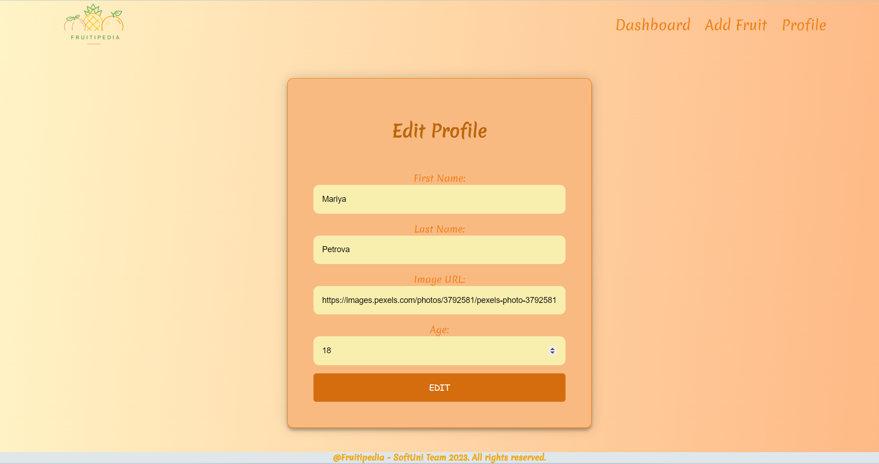

### Delete Profile Page - 5p

Template file: **"delete-profile.html"**

Deleting a profile should **delete** the **profile info** and **all** of **his**/**her fruit posts**.After **deletion**, the user should be redirected to the **index page**.

